https://www.methodist.org.uk/faith/a-methodist-way-of-life/
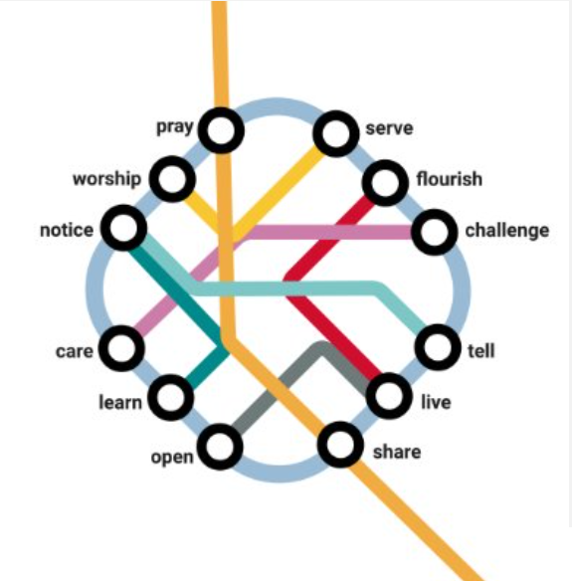
At a recent Mission Planning training day, those present were challenged to look at the Methodist Way of Life image and try to identify each station on the map for each church or mission area in our Circuit – let’s call them mission delivery points, because these include the New People New Places initiatives. It was an exercise in understanding our starting point before we began looking forward.
We were more successful in some areas than others and it became quite clear that we don’t have a full picture of what we do in our mission delivery points – our CHURCH on multiple sites. So, if we don’t know what we are doing now, how can we Mission Plan for the future?
You will see that we have attached a copy of what we think we know about you. Please can you complete out knowledge. Some may have this information to hand, for others it’s an opportunity to think, pray and reflect, before answering.
John Hawkins – Circuit Steward

The Circuit Office will collate the information for us to consider in our Circuit Mission Plan.
Please aim to reply by Monday 31 March 2025.
(Although, you may wish to return it at The Circuit Meeting is on 26 Mar 25)

Mission Delivery Point Name:
Regular Sunday Attendance No:
Other Worship Attendance No:
No Individuals reached by Mission Delivery Point (regardless of how many times they attend):

Please list the activities, both Christian and secular, that your Mission Delivery Point is involved in - giving days, times, participation. (Please be as accurate with numbers as possible and continue on additional pages.)

>>>>> You may wish to use this same document as a source for your own local Mission Plan <<<<<

If you wish to use the table below as you type the boxes should expand to give you the space, you need -
Day of Week | Time & Duration | Activity  Details | Average Attendance

